Model Case 1. Utility model patent
Case circumstances
In 2013 an application for a grant of utility model patent “The system of automatic illegal parking determination” was filed to the Federal Service for Intellectual Property of Russia (FSIP).
FSIP decided to refuse the application. FSIP indicated that the claimed object was a distributed information system and its parts had no constructional unity, the specified gadgets, namely video camera and electronic device, were separated in space and did not have a single frame. Thus, the claimed technical solution was not recognized as an apparatus and could not be protected as a utility model.
The applicant for a patent appealed against the decision of FSIP. On his mind the claimed utility model conforms fully to determination of an apparatus insofar as it presents video camera and electronic device that are connected by a wireless or wiring data communication channel. Due to such integration the new device appears and its parts have constructional and functional unity.
Following the examination FSIP decided to dismiss an appeal.
Questions
1. What does the notion “unite construction or product” mean in respect of the requirements of the Article 1351 of the Civil Code of the Russian Federation? Does this notion mean a physical connection of devices in a unite frame for a joint use?
2. Is it possible to grant a utility model patent on a system of devices?
Model Case 2. «ФАМИЛИЯ» (“FAMILIA”)
Case circumstances
In 2004 the Federal Service for Intellectual Property registered a combined trademark “FAMILIA” (means “family, family name” in Russian) in respect of 35th class services of the Nice Convention, which includes sales promotion for others, procurement services for others (purchasing goods and services for other businesses).

The plaintiff filed a lawsuit seeking an early termination of the trademark protection on the ground of non-use.
According to the trademark owner the usage of the trademark is approved by the license agreement which came into effect in 2015. As by this agreement an exclusive right and license to use the trademark were granted to the third party. The trademark owner also presented privilege cards which were marked with the trademark and used in retail chain. Alongside with that the emission date of the privilege cards was not determined.
Questions
1. Could the privilege cards’ presentation by customers be recognized as the trademark’s usage in respect of 35th class service of the Nice Convention? Would the trademark’s usage be recognized during the term of privilege cards’ validity?
2. Which fact has legal bearing in respect of the Article 1486 of the Civil Code of the Russian Federation: the trademark’s allocation on the privilege card or the actual use of this card by a customer?
Model Case 3. «Точь-в-точь/Один в один»(“Toch’-v-Toch’/Odin v Odin”)
Case circumstances

Gestmusic Endmoll S.A. (rights holder) and CJSC “VaiT Media” (licensee) filed a lawsuit seeking a protection for an exclusive right for a TV-format.

The plaintiffs put the infringement lawsuit against JSC “Perviy Kanal” (“First Channel”) for injunctive relief against the production and managing any TV-shows based on the TV-format of the show “Te cara me suena” (“Your Face Sounds Familiar”) and for consideration.
In 2011 the rights holder started up the TV-show “Te cara me suena” in Spain and later worked out the TV-format’s production Bible called “Your Face Sounds Familiar”. At the moment Gestmusic Endmoll S.A. holds the rights on the disputed TV-format and grants the right to produce TV-shows in different countries. The exclusive right to use the TV-formant in Russia was granted to CJSC “VaiT Media”. The licensee started up the production of the show “Odin v Odin” (means “like two peas in a pod” in Russian) in collaboration with JSC “Perviy Kanal”.
However JSC “Perviy Kanal” violated its obligation to pay licensing fees. As a result CJSC “VaiT Media” granted an exclusive right to produce the show to the federal state unitary enterprise "The Russian Television and Radio Broadcasting Company" (VGTRK, RTR). At the same time JSC “Perviy Kanal” started up its own show called “Toch’-v-Toch’” (means “perfect match” in Russian). As “Odin v Odin” this show is also a parody TV-show.
Questions
1. Does the TV-format have any legal protection?
2. Is it possible to protect exclusive rights for a production Bible of the TV-show?

Model Case 4. «СПОРТИВНЫЙ» (“SPORTIVNYI”)
Case circumstances

In 2010 an application for registration of a trademark (service mark) as a verbal denomination “SPORTIVNYI” (means “sporty” in Russian) in respect of 5th class goods of the Nice Classification (dietetic substances adapted for medical use, hematogen, dietary mineral supplements for medical purposes, caramel for medical purposes, medical sweets, vitamin products, dietary protein products for medical purposes, food for babies, dietary food) was filed to the Federal Service for Intellectual Property of Russia (FSIP).
Following the results of the legal examination of the application a verbal denomination “SPORTIVNYI” was found similar to the point of confusion with the trademark “SPORTY” registered in respect of uniform goods of 5th class of the Nice Classification with a priority date of 2002. It was decided to deny the application according to paragraph 6 of Article 1483 of the Civil Code of the Russian Federation.
In 2011 FSIP cancelled the trademark “SPORTY” registration in respect of all goods of class 5th of the Nice Classification.
In 2013 following the results of the examination of the application FSIP denied the registration of a designation “SPORTIVNYI” on the grounds set out in paragraph 1 of the Article 1483 of the Civil Code of the Russian Federation. FSIP mentioned that the declared designation did not have distinguishing capability as far as it indicated the intended purpose of the goods of class 5th of the Nice Classification.
Questions
1. The intended purpose of the good usually means a capacity to satisfy a demand for something. What designation can be recognized as indicating the intended purpose of the goods?
2. In order to recognize a designation as descriptive on the grounds of indication the intended purpose, would it be sufficient to establish that:
- a designation points out that the goods are addressed to a particular group of consumers,
- or a designation points out that the goods are addressed, among others, to a particular group of consumers,
- or a designation points out a particular effect, which consumers obtain from the goods,
- or goods primarily satisfy the needs of consumers that are not connected associatively with a designation, but they [goods] can also be used for some intended purpose indicated by the designation?
Model Case 5. «В КРУГУ СЕМЬИ» (“V KRUGU SEMYI”)
Case circumstances
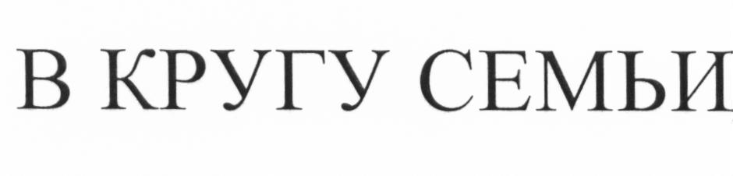
In June 2012 an application for registration of a verbal trademark (service mark) “V KRUGU SEMYI” (means “in the bosom of the family” in Russian) in respect of 33rd class goods of the Nice Classification “alcoholic beverages (except beers)” was filed to the Federal Service for Intellectual Property of Russia (FSIP).
The registration of the claimed service mark was denied on the ground of violating the requirements of subparagraph 2 of paragraph 3 of Article 1483 of the Civil Code of the Russian Federation. In virtue of its sensing this designation was recognized as violating public interests, rules of morality and humanity in respect of good “alcoholic beverages”.
The applicant appealed the FSIP’s decision and filed an objection. In the objection the applicant referred to a great number of trademarks containing the word “SEM’YA” (means “family” in Russian) and existence trademarks with denominatives of the words “MAMA” (“mother”), “RODN’YA” (“relatives”), “SESTRA” (“sister”) registered in respect of 33rd class of goods of the Nice Classification
FSIP denied the objection.
Questions
1. What designations are recognized as violating public interests, rules of morality and humanity?
2. What facts ought to be settled by the court if the disputed designation does not meet the requirements of subparagraph 2 of paragraph 3 of Article 1483 of the Civil Code of the Russian Federation?
Model Case 6. “FAIRY”
Case circumstances
In 2007 the Federal Service for Intellectual Property of Russia (FSIP) registered a three-dimensional trademark in respect of 3rd class goods of the Nice Classification (bleaching preparations and other substances for laundry use; cleaning, polishing, scouring and abrasive preparations; soaps; perfumery, essential oils, cosmetics, hair lotions; dentifrices).
In 2015 the legal protection of this trademark was cancelled as violating the requirements of paragraph 1 of Article 6 of the Trademark Law 1992 (a designation representing a form of goods that is defined exclusively or mainly by the properties or intended purpose of the goods).
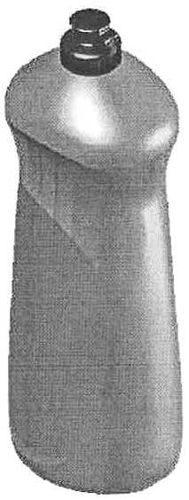
FSIP mentioned that a three-dimensional designation registered as a trademark did not have distinguishing capability both before the priority date and at the moment of sustaining objection. It presents a traditional shape of container for cleanser producers that prevent a bottle from slipping out during the exploitation. As a result this shape determines the functional purpose. Grant of an exclusive right on a three-dimensional designation with a traditional shape to one trader violates the right of others to use it. Furthermore similar volumes had already been represented on the Russian market long before the priority date of the trademark.
Questions
1. What criteria should be taken into account in making an assessment of a three-dimensional trademark in order to its distinguishing capability?
2. What does the “traditional shape” mean?

